School of Computing Science and Engineering

LAB – 5, 6 Exercises

Problem- 1:

Write a Naïve Bayes Classifier in python without using any package for the following dataset

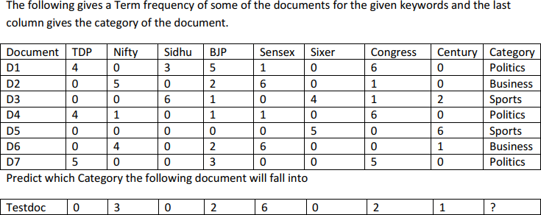

Challenging Exercise-1:

Take any set of web pages, do the necessary preprocessing and build a Naïve Bayes Classifier and draw the inferences.